PowerRun 2015 Route
Connect with us

6/16/2015

Hansie Louw 081 2711 570

The full map is here – bitly.com/powerrun2015map (interactive map)

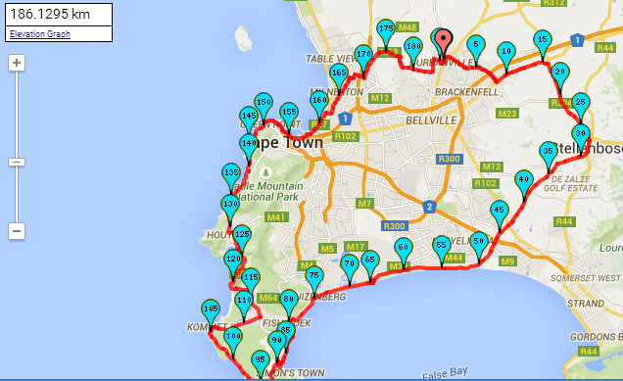

Roete:
Endomondo.com – 1Powerrun (46km)
Gaan na Wellington Weg en draai regs.
By m15 draai regs tot by R101. Draai links tot en gaan tot by R304.
Draai regs Stellenbosch toe. In Stellenbosch regs or R44 en by stasie weer regs op R310
Hou op Baden Powell en tot by Cape Film Studio afdraai omtrent by n2.

Endomondo.com – 2powerrun (47 km)
Bly op Baden Powell tot by Main road Muizenburg. Draai links.
Bly op die pad tot amper in Simonstad en draai dan regs in Red Hill Road (M65)

Endomondo.com – 3Powerrun (39 km)
Bly op M65 langs die kus (nie kortpad by Kommetjie nie).
Draai links op M6 in Noordhoek en amper dadelik weer links oppad na Chapmanspeak.
Gaan tot in Houtbaai by die hoek van m6 en m65. Draai hier na Suikerbossie en Llandudno toe.
Endomondo.com – 4Powerrun (36 km)
Bly op m6 langs die see tot by Beach Road in Mouille Punt. Volg dit.
Gaan deur hawe en dan op R27 en draai regs in Boundary Road net na Lagoon Beach Hotel.
Draai links in Koeberg weg en regs net na Click Play (Stella Cove) –
Endomondo.com – 5Powerrun (18 km)
volg pad verby Makro tot by Plattekloofweg en draai regs.
Draai links by die sirkel en hou op die pad (Tygervalleipad) tot by St Johns in Durbanville en draai links.
Gaan verby Wellingtonweg en draai links in kerk; Links in Chenowethstraat en regs in Marais straat.
The full map is here – bitly.com/powerrun2015map (interactive map) Anita 082 928 8581
 | Google maps points | Area
Start | -33.829373, 18.651293 | 15 Marais Street, Durbanville
1 | -33.844989, 18.714459 | c/o Langeberg and Okavango
2 | -33.837736, 18.768639 | 2,2 km in front of R304 on R101
3 | -33.860847, 18.813421 | Bottelary Road, 1 km prior to that on R304
4 | -33.908100, 18.845885 | opposite Cloetesville Sports Grounds
5 | -33.945898, 18.826436 | R310 c/o vredenburg road & adam tas
6 | -33.982617, 18.770720 | R310 - Annandale Road
7 | -34.032316, 18.727890 | R310 - turn off to Cape Town Film Studios
8 | -34.071455, 18.668506 | Baden Powell - M49 Corner - Swartklip Rd
9 | -34.070779, 18.617437 | Baden Powell - Eisleben Road
10 | -34.085477, 18.553021 | Baden powell - M17
11 | -34.102518, 18.480601 | Baden Powell - M5
12 | -34.126191, 18.449659 | Kalk Bay Station
13 | -34.163449, 18.431592 | Glencairn Station
 | -34.179924, 18.425090 | Turn here up Redhill
14 | -34.189707, 18.412459 | Redhill - at private Road
15 | -34.194229, 18.370977 | Cape Point Lodge - 37 Main Rd Scarbarough
16 | -34.141652, 18.325355 | Beach Road, Kommetjie Rd (m65)
17 | -34.132599, 18.382684 | Lekkerwater Rd, Kommetjie Rd (m65)
 | -34.120835, 18.391874 | Turn left M6 and again left into Noordhoek Main Road
18 | -34.097223, 18.377304 | Noordhoek Farm Village no 9 - Noordhoek Main Road -
19 | -34.061785, 18.371060 | Chappies - 021 791 8220 or /2
20 | -34.029746, 18.356319 | Finish day 1 - Houtbay
sleep | -34.006883, 18.348883 | Apostile Battery - camp site
 | -34.029746, 18.356319 | c/o m6 and m65
21 | -34.011036, 18.349463 | Top of Suikerbossie
22 | -33.970407, 18.371375 | 45 Victoria Rd - close to Bakoven
23 | -33.926668, 18.378930 | Ambassador Hotel
24 | -33.916566, 18.432913 | V&A Waterfront -c/0 Duncan and Heerengracht
25 | -33.891633, 18.485355 | Lagoon Beach Hotel - 330 Marine Drive
26 | -33.851124, 18.519253 | Click Play, Koeberg Road, Montague Gardens
27 | -33.832945, 18.547555 | 7-11 Richwood
28 | -33.838693, 18.599526 | Bloemendal Wines
29 | -33.831695, 18.635861 | Corner Hoog and St John
30 | -33.829373, 18.651293 | Finish - 15 Marais Street
Start
